Phigit class
Graham Bantock recently asked me if I’d seen the free plan in January’s Marine Modelling International for Charles Détriché’s RC yacht ‘Estrellita’. I seem to remember mumbling a non-committal reply as I continued my detailed appreciation of a slice of Lorna’s fruit cake, but Graham knew how to get my attention. “It carries a standard IOM rig on a rather nice hull, and has IOM appendages”, he continued. “There might be interest in a class which uses freely available IOM sails and rigs but in which there were few restrictions on the hull.” My day job has meant I’ve retired to the background of the IOM International Class Association, but I’m always interested in anything which might help promote and develop the IOM, so I spoke to Chris Jackson, MMI Editor.
Chris was enthusiastic. “A free hull shape allows overhangs”, he explained, “so as well as looking classically attractive, the design picks up sailing length on the beat while eliminating nose-diving on the run.” Chris added that MMI would like to support some regattas in 2007 if there was sufficient interest, and he had asked Graham and Charles if they would care to oversee the development of a set of class rules in consultation with interested owners and builders. I offered some ideas around minimising demands on class measurement, certification, and administration, and discovered I had apparently volunteered to help the three of them develop the project.
I e-mailed Charles, and he was equally enthusiastic. “I think the key points for an economical and simple boat”, he wrote, “are that it should use IOM rigs and foils, and allow home building.” If it is to become a class, Charles thought it should “not give especially light construction any advantage”, and should also have “easy measurement and certification.”
Following Chris’ follow-up article on ‘Estrellita’ in the August MMI, a number of owners put forward their names as being interested in developing what is now being called the ‘Phigit’ class. I contacted these owners and discussed various ideas around the basic class concept, its technical parameters, measurement, certification, and administration. This article summarises the outcomes of these discussions, and outlines a possible way in which the ‘Phigit’ class would develop.

Basic class concept
The new class would use IOM rigs and foils. It would not put a home builder at any disadvantage by comparison with an expert or professionally made boat. In particular, super-light construction would bring no advantage. The class would not restrict the number of radio control channels (but the extra channels could not be used for canting keels, keel trim tabs, or any movable ballast). For a home-build boat, the class would offer exceptionally easy measurement and certification. An easy vertical centre of gravity (VCG) measurement would deal with all weights and placements issues at one stroke. A simple transverse depth gauge would control overall draught. Owners would self-certify their boats, and sail makers would be licensed to self-certify sails. Random checks at events would ensure rules compliance. Finally, all class matters would be dealt with via a Web site and e-mail.

Technical parameters
Hull
The hull would be a monohull, but not be limited in overall length. It is likely that many designs will settle on a LOA of around 1.5 m. Hollows would not be allowed in the hull, and to achieve this something like the Ten Rater (10R) rule would be followed. Only the deck could have hollows, and everywhere else a 300 mm straightedge should not be able to detect any hollows greater than 1 mm deep. A 10R-style bumper would be required, on the assumption that the hull would have overhangs. And, hull materials would be free. The boat would have a minimum displacement of 4.25 kg. This permits low tech construction. The higher displacement also means that the boats will accelerate and decelerate slightly slower making mark rounding a little more predictable. The boat would have an overall draught limit. The actual draught limit would be such that existing IOM appendages could be used without modification. There would be no canoe body depth restriction.
Appendages
While only one (fixed) IOM-style keel would be permitted, there would be no restriction on the number or placement of rudders.
Sails and rigs
Sails and rigs would conform to the IOM class rules. In summary, 3 rigs would be permitted, spars would be aluminium alloy or wood, the mast minimum diameter would be 10.7 mm, and sail areas and shape would be “IOM one-design”. Using IOM sails and rigs means there is ready availability of well-understood and relatively inexpensive parts. Furthermore, owners could take an IOM hull and a Phigit hull to the pond, and chose which one they wished to sail at a fun regatta while using their common rigs.
Radio control
The number of radio control channels would not be limited, so 4 (or more) channel RC equipment could be used to explore multiple trimming functions. The use of the extra channels would be limited, however, and canting keels, trim tabs, or any form of movable ballast would not be permitted.
Insignia
Finally, the insignia would be a filled circle, like the IOM insignia, but with a vertical bar. This looks something like the Greek letter “phi”, hence the class name! The intent here is that the owner could lightly apply a length of sticky black tape, about the size of a “1” sail digit, over the IOM insignia to create the ‘Phigit’ class insignia, and then easily remove the tape if the rig is to be used later for IOM racing:

Measurement
I think some of the most exciting concepts of the ‘Phigit’ class would be found in its approach to certification and measurement.
Depth gauge
We wanted to avoid measurement drudgery as far as possible. So draught would be checked using a Marblehead-type transverse gauge, and no flotation tank would be necessary. Figure 1 shows such a gauge in use. The size of the gauge is such that an IOM keel fitted to an Phigit hull just slips through, and has jaws about 75 mm wide, and 380 mm deep.

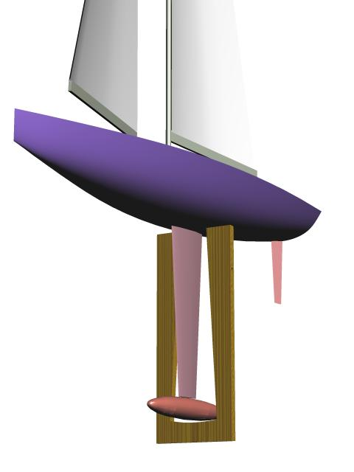
Figure 1. Transverse depth gauge

A longitudinal gauge was considered. It is an attractive option because it may avoid any tendency to encourage distorted hull cross sections, but it isn’t viable in a class with neither fixed overall length nor waterline measurement marks placed on the hull.
Vertical centre of gravity gauge
More importantly, instead of being concerned with restricting hull depth, or with weights and their placement, the whole boat would be checked by an easy vertical centre of gravity (VCG) test. Figure 2 shows a boat being tested using the simple VCG gauge. The boat passes if it tips off the gauge fulcrum, and fails the test if it stays on the gauge. The suggested VCG distance of 245 mm should allow a 4.25 kg Phigit boat rigged with an IOM No.1 suit to just tip off with a 2.5 kg (IOM) keel. The VCG test means that it would not help an owner to build a super-light hull and put corrector weights in the bottom of the hull.

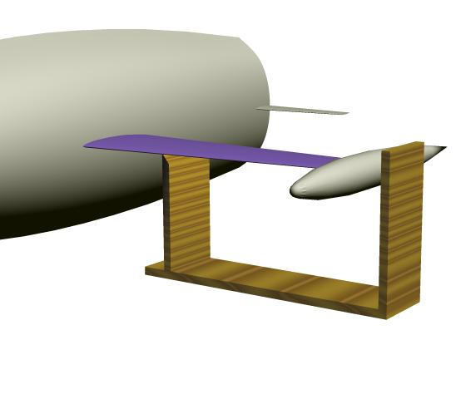
Figure 1. Vertical centre of gravity measurement gauge

Sails
Finally, new sails would be measured in one of two ways. In the conventional way, an official measurer would need to certify that the sails meet the IOM class rules. Or, in a new method which the Phigit class would pilot, sail makers would be licensed so they could sell self-certified sails. Of course, if an owner was going to use an existing IOM rig, the sails would already be measured, and so nothing further would need to be done for certification.

Certification and racing
Following the concept pioneered in full-size by the IMS rating rule, owners would be able to self-certify their boats, and be issued a certificate based simply upon their signature saying, “Yes, I’ve done the measurements and my boat meets the class rules”.
It would only be at an event that boats would be inspected and possibly check-measured, using the same gauges and tools that an owner would use.

Administration of the class
In the short term, a Class Management Group (CMG) will be formed by Charles, Graham, and myself, and would take on several tasks:
- Construct a Web site and Internet forum for class management.
- Register class owners.
- Issue hull numbers and certificates.
- Interpret the class rules upon request.
- Develop the class rules in light of experience.
- Form an Phigit Class Association.
In the long term, the CMG would become the Executive Committee of the Phigit Class Association (Phigit CA). Owners would join this single, international, Phigit CA, and would elect its CMG directly. The Phigit CA would deal with all technical, measurement, and class management issues, and all registered owners would have a direct say in this. In any country where the class is sailed, a group of interested persons may well get together to form a national Phigit association for the purposes of promoting the class and arranging class regattas and coordinating class regatta dates with the associations of other classes in the country.
Lester Gilbert
August 2006
[Approx 0 words]

